Final
from collections import deque, defaultdict

# --- Build the undirected graph from the image ---
edges = [
("A","B"), ("A","C"),
("B","D"), ("B","E"),
("D","F"),
("E","G"), ("E","H"),
("G","I"), ("G","J"),
("I","L"), ("J","L"),
("H","K"),
]

graph = defaultdict(list)
for u, v in edges:
graph[u].append(v)
graph[v].append(u)

# keep traversal deterministic
for u in graph:
graph[u].sort()

# --- BFS ---
def bfs(start):
visited = set([start])
order = []
q = deque([start])
while q:
u = q.popleft()
order.append(u)
for v in graph[u]:
if v not in visited:
visited.add(v)
q.append(v)
return order

# --- DFS (recursive) ---
def dfs(start):
visited = set()
order = []
def rec(u):
visited.add(u)
order.append(u)
for v in graph[u]:
if v not in visited:
rec(v)
rec(start)
return order

# Run from A
bfs_order = bfs("A")
dfs_order = dfs("A")

print("BFS order:", bfs_order)
print("DFS order:", dfs_order)

# (Optional) show sizes for time-complexity reference
V = len(graph)
E = len(edges)
print(f"|V| = {V}, |E| = {E} -> both BFS and DFS run in O(V + E)")
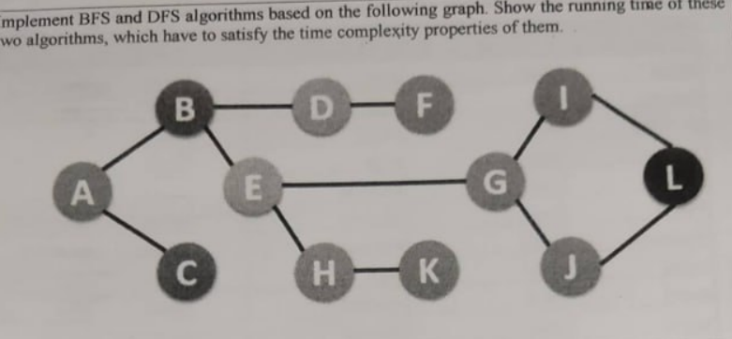

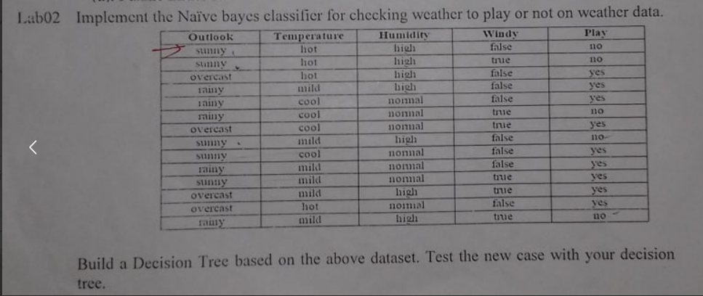
import pandas as pd
from sklearn.preprocessing import LabelEncoder
from sklearn.naive_bayes import CategoricalNB
from sklearn.tree import DecisionTreeClassifier, export_text

data = {
'Outlook': ['sunny','sunny','overcast','rainy','rainy','rainy','overcast','sunny','sunny','rainy','sunny','overcast','overcast','rainy'],
'Temperature': ['hot','hot','hot','mild','cool','cool','cool','mild','cool','mild','mild','hot','mild','mild'],
'Humidity': ['high','high','high','high','normal','normal','normal','high','normal','normal','normal','high','normal','high'],
'Windy': ['false','true','false','false','false','true','true','false','false','false','true','true','false','true'],
'Play': ['no','no','yes','yes','yes','no','yes','no','yes','yes','yes','yes','yes','no']
}

df = pd.DataFrame(data)

encoders = {}
encoded = pd.DataFrame()

for col in df.columns:
le = LabelEncoder()
encoded[col] = le.fit_transform(df[col])
encoders[col] = le

X = encoded[['Outlook','Temperature','Humidity','Windy']]
y = encoded['Play']

nb = CategoricalNB()
nb.fit(X, y)

dt = DecisionTreeClassifier(criterion='entropy', random_state=0)
dt.fit(X, y)

def predict_both(outlook, temp, humidity, windy):
test = pd.DataFrame({
'Outlook':[outlook],
'Temperature':[temp],
'Humidity':[humidity],
'Windy':[windy]
})
enc = pd.DataFrame()
for c in test.columns:
enc[c] = encoders[c].transform(test[c])
nb_pred = encoders['Play'].inverse_transform(nb.predict(enc))[0]
dt_pred = encoders['Play'].inverse_transform(dt.predict(enc))[0]
return nb_pred, dt_pred

case1 = dict(outlook='sunny', temp='cool', humidity='high', windy='true')
case2 = dict(outlook='rainy', temp='mild', humidity='normal', windy='false')

nb_result1, dt_result1 = predict_both(**case1)
nb_result2, dt_result2 = predict_both(**case2)

print("=== Test Case 1 ===")
print(case1)
print("Naive Bayes:", nb_result1)
print("Decision Tree:", dt_result1)

print("\n=== Test Case 2 ===")
print(case2)
print("Naive Bayes:", nb_result2)
print("Decision Tree:", dt_result2)

rules = export_text(dt, feature_names=['Outlook','Temperature','Humidity','Windy'])
print("\n=== Decision Tree Rules ===")
print(rules)

A star final
import heapq

# heuristic values from the image
h = {'A': 11, 'B': 6, 'C': 99, 'D': 1, 'E': 7, 'G': 0}

# undirected weighted graph from the image
graph = {
'A': {'B': 2, 'E': 3},
'B': {'A': 2, 'C': 1, 'G': 9},
'C': {'B': 1},
'E': {'A': 3, 'D': 6},
'D': {'E': 6, 'G': 1},
'G': {'B': 9, 'D': 1}
}

def a_star(start, goal):
open_heap = [(h[start], 0, start)] # (f=g+h, g, node)
came_from = {}
g_score = {start: 0}
visited_order = []

in_open = {start}

while open_heap:
f, g, u = heapq.heappop(open_heap)
in_open.discard(u)
visited_order.append(u)
if u == goal:
path = [u]
while u in came_from:
u = came_from[u]
path.append(u)
path.reverse()
return path, g_score[goal], visited_order

for v, w in graph[u].items():
tentative = g_score[u] + w
if tentative < g_score.get(v, float('inf')):
came_from[v] = u
g_score[v] = tentative
f_v = tentative + h[v]
if v not in in_open:
heapq.heappush(open_heap, (f_v, tentative, v))
in_open.add(v)

return None, float('inf'), visited_order

path, cost, expanded = a_star('A', 'G')

print("Expanded order:", expanded)
print("Best path:", " -> ".join(path))
print("Total cost:", cost)

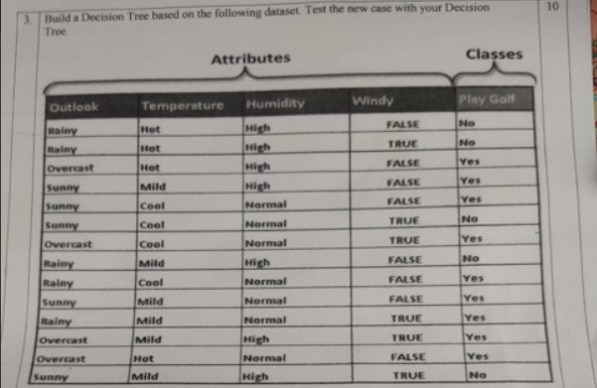
import pandas as pd
from sklearn.preprocessing import LabelEncoder
from sklearn.tree import DecisionTreeClassifier, export_text

data = {
'Outlook': ['Rainy','Rainy','Overcast','Sunny','Sunny','Sunny','Overcast','Rainy',
'Rainy','Sunny','Rainy','Overcast','Overcast','Sunny'],
'Temperature': ['Hot','Hot','Hot','Mild','Cool','Cool','Cool','Mild',
'Cool','Mild','Mild','Mild','Hot','Mild'],
'Humidity': ['High','High','High','High','Normal','Normal','Normal','High',
'Normal','Normal','Normal','High','Normal','High'],
'Windy': ['FALSE','TRUE','FALSE','FALSE','FALSE','TRUE','TRUE','FALSE',
'FALSE','FALSE','TRUE','TRUE','FALSE','TRUE'],
'Play Golf': ['No','No','Yes','Yes','Yes','No','Yes','No',
'Yes','Yes','Yes','Yes','Yes','No']
}

df = pd.DataFrame(data)

encoders = {}
encoded = pd.DataFrame()
for col in df.columns:
le = LabelEncoder()
encoded[col] = le.fit_transform(df[col])
encoders[col] = le

X = encoded[['Outlook','Temperature','Humidity','Windy']]
y = encoded['Play Golf']

dt = DecisionTreeClassifier(criterion='entropy', random_state=0)
dt.fit(X, y)

new_case = pd.DataFrame({
'Outlook': ['Sunny'],
'Temperature': ['Mild'],
'Humidity': ['High'],
'Windy': ['TRUE']
})

enc_new = pd.DataFrame()
for c in new_case.columns:
enc_new[c] = encoders[c].transform(new_case[c])

pred = dt.predict(enc_new)
result = encoders['Play Golf'].inverse_transform(pred)[0]

print("=== New Case ===")
print(new_case)
print("Prediction (Play Golf):", result)

rules = export_text(dt, feature_names=['Outlook','Temperature','Humidity','Windy'])
print("\n=== Decision Tree Rules (Entropy / ID3) ===")
print(rules)

